Image acquisition

In this phase, all the sample images were collected. We chose both Green and Red apple species in this test. And, amongst the sample images we included at least 5 images from each of the 3 Diseases and from healthy apples. One of the major problems was that we could not collect Images on our own due to the pandemic situation, So we had to rely on Images that were found on the Internet. All the references of those images are mentioned ________.

Images of the diseases and healthy apples are shown by figure 1, figure 2, figure 3 and figure 4.

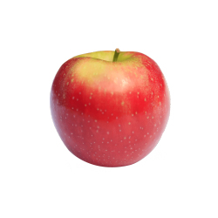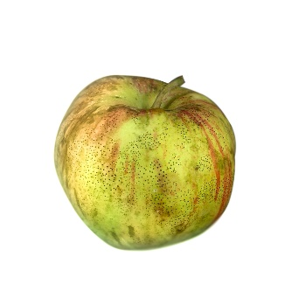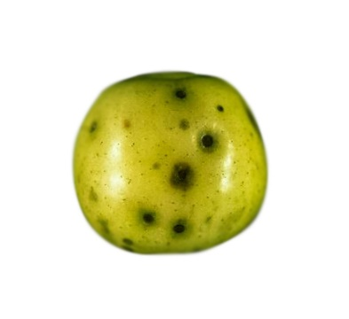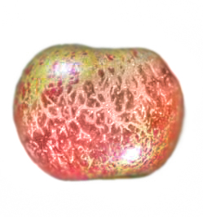

Figure 1

Healthy Apple